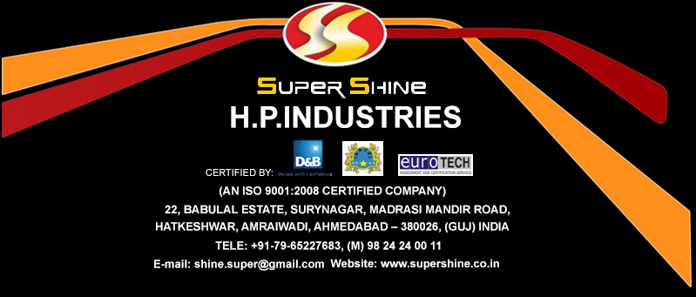
SUPERSHINE PAPER AIR FRESHENERS

PRODUCT INFORMATION AND BENEFITS:
Paper Air fresheners can be identified in cars and outlets everywhere because people love them! That’s why paper air fresheners are a successful way to draw attention to your company and communication in a HUGE way! We make paper air fresheners inexpensive. Advertise your business, meaning that is corporate or protection, simply every single day.
Volume custom Paper air fresheners branded at the cheapest rates together with your emblem or message. We’ve hundreds of investment styles, although we display only a few custom air fresheners, almost all you can imagine: contact us by telephone or E-Mail. Please suggest your design. Your wholesale paper air fresheners and the imprints on them are of the finest quality. Our wholesale paper air fresheners’ shelf life is minimum 24 months in seal pack condition. We utilize only best natural goods that are quality produced. We can also create absolutely custom shapes with a one-time custom die price. Personalized paper air fresheners don’t end up in a drawer like other giveaways. They hold in your customers’ cars to remind them about your merchandise for weeks, possibly years.
Promotional Custom Paper Air Fresheners for Marketing, Fundraisers events, Political Promotions.
Custom Paper Air fresheners are worthwhile smart technique, a smart way to grow your company in the retail market. Custom Air Fresheners are oftentimes an ideal sort of advertising in the market today.
Out-Smart Outsmart and Outsell Your Competitors with Individualized Air Fresheners!

Why custom Paper air fresheners are used?

- Paper air fresheners are little and not dark, outstanding for mailing.
- Increase repeat business
- Multi-purpose marketing – improve budget
- Attract More Attention!
- Create enthusiasm and awareness in services or target products
- Integrate store or discount data.
- Co-op marketing option – reveal the air freshener, 2 sided printing, share the charge – savings that are 50% that is instant!
- Cross Sell – Motivate customer to visit our website to view other offers that are fantastic
- Add boost and value commitment for advertising!

They’re also inexpensive and helpful report promotion surprise for new or enterprise products promotion. Mark, system dimension, condition, and aroma can be customized according to different events in compliance with the minimum volume of 1000pcs. To ensure that the consumer sees all the data, which can be to get, these are to be hanged around the front rear view mirror of cars. The paper air freshener will not merely perfume the car but also provide data on the maker and contact details. It can offer any additional information that is desired

PRODUCT DESCRIPTION: PROMOTIONAL PAPER AIR FRESHENERS
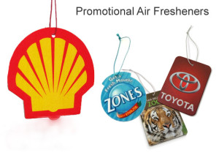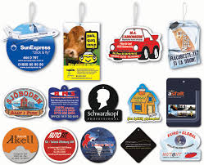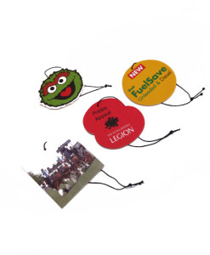
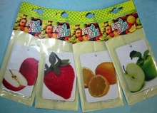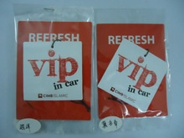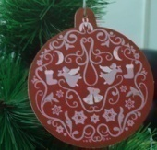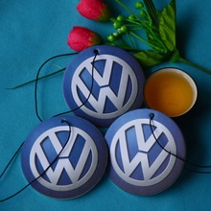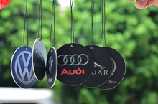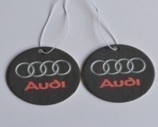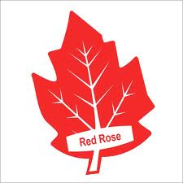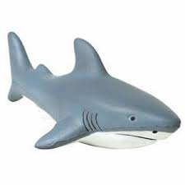
Item | Supershine Paper Air Freshener
Color | Red, Orange, yellow, blue, green or customized
Size | Customized
Thickness | Standard 2mm or customized
Handle | Hanging elastic string
Printing | Double printing
Feature | Eco-friendly, absorbent
Scents Lasting Time | Keep 2 years when not be opened, but the fragrance can last for 10-21 days once fully opened  & 20-60 days if opened partially.
Fragrances | Chocomusk, Fruity Vanilla, Citra Squash, Lavenderilla,  Musk Rose, Black Forest, Night Queen, Pinacolada and many more (can be customized)
Function | Fresh Air, Deodorant, Mildew,  Refreshing, Get rid of odor and other effects
Application | Car, Offices, Promotional Gift, Advertising, Hotels, Guesthouses, Home Bedroom, Bathroom,  Shoe Racks, and many more…
Detail Packaging | Per card per polybag , then 1000pcs/crtn
Print
The print process generally used is FULL COLOUR DIGITAL. This allows us to reproduce images in much greater detail than screen printing allows; although we can screen print as well if preferred.
When printing onto absorbent board that is then soaked in a fragrance it can be a challenge to achieve the desired end result. Over the years we have learnt a great deal.
However using this process it was sometimes difficult, if not impossible, to achieve the quality of print the client, and ourselves, expected and wanted on certain designs.
The increasing demands of creating a promotional and marketing product that contains more intricate information, greater detail and finer images led us to adopt full colour digital printing. The new digital printing process now offers the capability to successfully reproduce all these designs in glorious, detailed full colour.
Both sides of the freshener can be printed the same or not - both in terms of design and colors used at no additional cost.
Your air fresheners are produced on paper, which will be developed to absorb the smell. This may produce slight inconsistencies in the remains of inks. Images and images printed with this surface provide a lower-resolution. The layout you see on the monitor shows the craft but doesn’t demonstrate how the finished solution can look once produced on the air freshener report. Due to the substance and the generation process’ pure homes, line weight, and photography shades can vary. Moderate modifications and problems in the garbage might result in improvements that are possible to dimension, shape, color, markings, etc. These circumstances are within suitable our expectations and aren’t considered weaknesses. Fragrance influences the color of paper and may alter whites to a buff color. Fragrance longevity varies according to the smell and the atmosphere in which the air freshener is positioned.

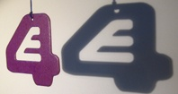
Shape
We treat each car air freshener as a unique design. There are no templates you must stick to which allows you the freedom to invent your own shape and to create a totally unique and personalised item.
The car air freshener is cut from a rectangular board measuring 90 x 70 millimeters. Any shape can be cut although there is a limit to how intricate the cutter can cut.
We can produce bigger sizes but this is not standard production.
Fragrances
Scent is one of our most powerful senses, and plays a crucial role in our emotional well-being. The majority of our fragrances contain essential oils in varying percentages. Oil purity is an important concern to anyone purchasing products that contain essential oils. There are many different grades of oils and we only use the highest quality grades in our fragrances, which make the overall effect more intense and also carry a richer bouquet than the lower grade oils.
It is fair to say that the process we follow results in a far greater absorption of the fragrance which results in a longer lasting scent.
Packaging
Our air fresheners are individually packaged in a barrier coated polypropylene film which prevents any loss of scent. This film has outstanding physical properties and has many advantages over other plastic products preventing loss of scent and ensuring the best and lightest presentation. The air fresheners supplied in bulk are packed in cartons.

SUPERSHINE PAPER AIR FRESHENERS
- We will not charge you for any setup cost and design. We ensure quality of a very high standard.
- Freshener prices are included with standard packaging. If you have or require special custom paper air freshener packaging design please doesn’t hesitate to contact us for price inquiry.
- Price is calculated for 70mm X 90mm dimensions with 2mm standard thickness.
- You can make your own air freshener design or we can do it for you. We don’t charge you for artwork.

Promotional products companies, wholesalers, retailers are also welcomed
Header Cards
The standard product is supplied in the polypropylene film wrapper only.
We can also manufacture a header card to enhance the presentation, printed to your specification and attached to the freshener. These are quoted for separately on sight of artwork.
A header card can be short or full length and can be printed on both sides. It offers a large canvas for your creativity.
Please do not hesitate to contact us to find out more and to discuss your project.
Call on 9824240011 Email: shine.super@gmail.com

